Importing Audio Files

You can import pre-recorded audio files into your project if they are in the following formats:
- WAV/RIF format (having .wav extension)
- MP3 format (having .mp3 extension)

Follow the steps given below to import audio files:
1. Select the section where the audio files should be placed.
2. To import audio files, click Phrases->Import Audio Files on the menu, or press Ctrl+I. An open dialog gets displayed that lets you browse for the files to be imported.
3. Select your files and click on the Open button. Obi will display the Import audio file settings dialog displaying the list of files selected by you, and some other controls enabling their manipulation as described below.
Figure: Import audio files settings
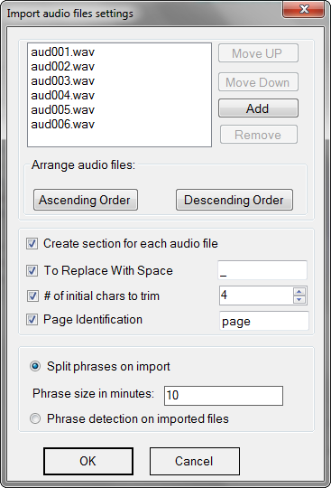

4. If you want to move a file above or below its adjacent file, select it and do any of the following:
a. Click on the Move file up button to move the selected file up by one position in the list.
b. Click on the Move file down button to move the selected file by one position down in the list.
5. To add more files to the list, click on the Add button. It opens a dialog box that lets you browse and select the required audio files.
6. You can also remove unneeded files from the list by selecting them in the list, and then pressing the Remove button.
7. Furthermore, you can sort the files in one go by using the Ascending order or Descending order buttons that will sort the files by their names.
8. To create a section for each selected file, check the checkbox Create a section for each audio file; this will also enable three more controls as described later in this topic.
9. Finally, you have an option to either apply phrase detection on the imported audio or restrict the length of each phrase via the following radio buttons:
a. Split phrases on import: Splits phrases if their length exceeds the size mentioned in the edit box Phrase size in minutes.
b. Apply phrase detection: Applies phrase detection on the imported audio and splits the phrases at the detected points.
10. Click on the OK button.

Please note that the files will be imported in the same order as they appear in the list of selected files in the Import audio file settings dialog. So, it is important to check and correct their order before starting the import process.

Obi will import the audio content from the selected files and store them as phrases according to the following set of rules.

By default, Obi will create a phrase for each audio file at the beginning of the selected section or after the selected phrase. The phrase will contain entire audio from the audio file. If the format or audio settings (channel and sampling rate) of the audio files are different from that of the project, the audio files will be converted before importing.

After importing audio, it will either be broken in the fragments of fixed size, or at the points determined using phrase detection.

If you opted to create a section for each audio file, new sections will be created after the selected section. The section will bear the same name as that of the audio file and contain the audio content from the respective file. If the selected section is empty, it will be replaced with the section corresponding to the first file.

Activation of this option also enables you to give the inputs for parsing and refining the section names as follows:
- To replace with space: A character that should be replaced with the space character in resulting section name, such as “_”. For example, if the files are named as “Chapter_1 and you type the character “_” in the edit box, the resulting section name will be “Chapter 1”.
- Number of initial chars to trim: Number of characters that should be trimmed from the beginning of the audio file name. For instance, if the file name is “001 Chapter 1” and you type in the number 4 in the edit box, the resulting section name will be “Chapter 1”.
- Page identification: A string that signifies that the audio file name contains audio for page number. In this case, Obi will not create a separate section for it but create a page phrase and append it to the previous section. But if the audio file name contains some alphabets other than this string, a new section will be created and the audio of page number will be stored therein. Please note that if this field is left blank, pages will not be appended to the previous section, but a new section will be created for each of them.

Please note that each of these options is preceded by a checkbox to activate or deactivate the respective option.

This function is very useful when you have pre-recorded audio content which has to be converted to a navigable DAISY book. The operation is designed in such a way that users will be able to produce DAISY book by just creating a new project, importing audio files, and exporting the project as daisy – THE PROCESS KNOWN AS AUTOMATED BOOK PRODUCTION.

Related Topics
Auto-splitting using Phrase Detection
Editing the Audio
Live Recording
Working with Audio

Previous Topic Top of the Topic Next Topic

